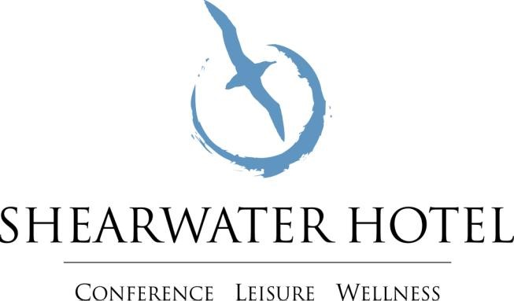

Fitness Class Pricing

Classes Free For Members:
- Bootcamp, Spin, Spin & Tone, Body Blitz, XXX Aqua Aerobics,

Pay As You Go:
- €8 per class for non-members
- Bootcamp, Spin, Spin & Tone, Body Blitz, XXX Aqua Aerobics,

Class Special Offer:
- €45 for 8 classes
- €75 for 12 classes
- Choose between Bootcamp, Spin, Spin & Tone, Body Blitz, XXX Aqua Aerobics,

